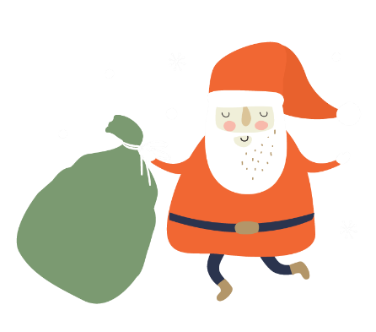

|  |  |  |  |
| --- | --- | --- | --- |
|  | BWD Counsellor’s Corner |  |  |
| November-December 2022 |
| Happy Holidays from our school family to yours!  My name is Michelle Waddell and I am the school counsellor here at Brentwood Elementary School.  **What does a school counsellor do?** I support the intellectual, emotional, and social development of all students through a continuum of preventative, developmental, and crisis intervention services. My role includes counselling, child advocacy, school-based consultation, coordination of services, and educational programming.  Please feel free to contact me at michelle.waddell@eips.ca | FREE Virtual Counselling   * Wellness Together Canada offers free virtual counselling. * Up to 5 sessions with the SAME counsellor * [www.wellnesstogether.ca](http://www.wellnesstogether.ca)   Woman attending virtual therapy    Alberta Health Services offers FREE virtual sessions for caregivers on topics including technology, depression & promoting success in learning. For more info, go to [www.cyfcaregivereducation.ca](http://www.cyfcaregivereducation.ca) |
| Page 1 | | | |



|  |  |  |  |
| --- | --- | --- | --- |
|  |  |  |  |
| Help for the Holidays  Strathcona Christmas Bureau  If you and your family need assistance over the holidays, please contact the Strathcona Christmas Bureau at 780-918-2521 for a hamper of food and gifts.  Wrapped holiday gifts  Thanksgiving feast |
| Logo, company name  Description automatically generated    Parenting Resources  The ChildPsych Podcast brings to you the top parenting and mental health experts in the world. Designed to educate and inspire you with current research and concrete strategies that foster resiliency and healing in children and teens.  The Ask Lisa Podcast is hosted by Dr. Lisa Damour, who provides an informed and practical perspective on our most timely parenting questions. |
| Page 2 | | | |