Agenda – February 27, 2023
Virtual

- Call to order- 6:33 pm Sarah Topliko

- Treaty 6 – We acknowledge that we are on Treaty 6 territory, a traditional meeting grounds, gathering place, and travelling route to the Cree, Saulteaux, Blackfoot, Métis, Dene and Nakota Sioux. We acknowledge all the many First Nations, Métis, and Inuit whose footsteps have marked these lands for centuries.

- Principles Report – Gary Russell
Increase in all catergories, teachers have added extra trips for next year
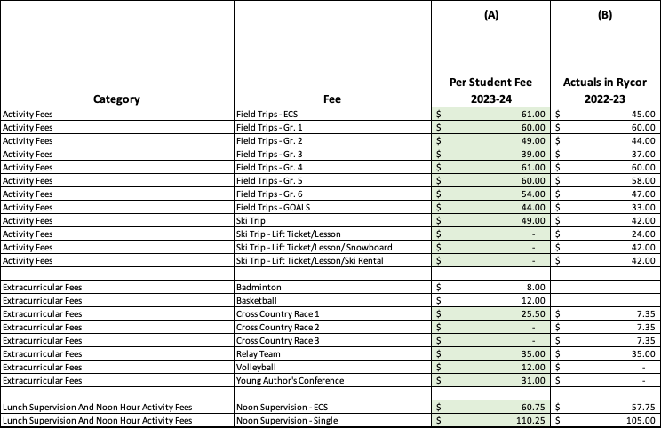

- Trustee Report-Don Irwin
Tabled

- ECS Report – Jody Blashko
Tabled

- LOGOS Report- Kindra Varty
Tabled

- Newsletter Updates: Jackie Szydlowski
To mention Save on foods location specific with receipts
Update on revenue from hot lunch

- Next Meeting: April 27, 2023 *Please note there will be no meeting in March

- Adjourn 6:43 pm Sarah, Leanne seconds

