Agenda – January 24, 2024
Brentwood Elementary Commons (Library)
6:30pm -7:15pm (Fundraising meeting to follow)

- Call to order- Kindra Varty 6:33pm

- Treaty 6 – Kindra Varty

- Welcome and introductions-Kindra Varty (2 minutes)

- Review & Approval of the Agenda- Kindra Varty(2 minutes)
- Call for any additions to the agenda
- Approval by Brian of the agenda and second by Roseanna

- Trustee Report-Don Irwin (5 minutes)

﻿I hope that you and your family had a relaxing time together over Christmas.
I have enclosed a link to the annual Education and Results report overview which shows that we as a School District are doing very well in providing high-quality student centred education to the 17,760 students in Elk Island Public Schools. You may go to eips.ca/ planning and results for the full 80 page document.
The Sport for Life program at Cloverbar Jr. High was adopted as an Alternative Program able to be used by any Junior High in EPIS. Also Developing Personal Values course was approved for use in the District as requested by Next Steps.
The Board heard a report on the use of Artificial Intelligence and working on policy for its use in schools.
A few of the areas that we are working on in January and February include the French immersion plan and also the design of Sherwood Heights school.
A plan for French Immersion in Grades 10-12 will be on the January 25 Public Board Meeting with all details available on Monday January 22 at noon on the District website.
The monthly COSC (Committee of School Councils) meeting was held Wednesday at at 6:30 PM January 10 and the summary of the meeting will be posted on the EIPS website after meeting. Much good information is relayed at these meetings, and I hope you have representative there to collect the information and then inform your school council. The Engagement Grant has been extended to January 31. You can attend in person at the Board Office or virtually on Zoom. February meeting will be held on February 7, 2024.
I would encourage all students, families and staff to be especially diligent about maintaining a healthy lifestyle, especially including handwashing, as we are in the midst of flu season.
If you have suggestions or questions from School Council or on any other items related to the board, please send them to me email preferred at don.irwin@eips.ca or text 587-986-3900

- Principal’s Report: Principal – Garry Russell & John Murphy (15 minutes)
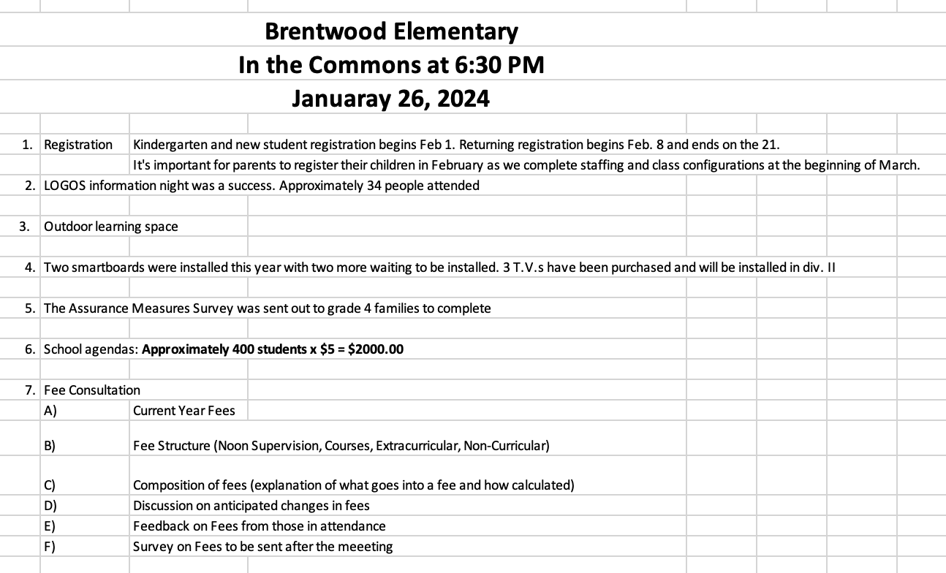

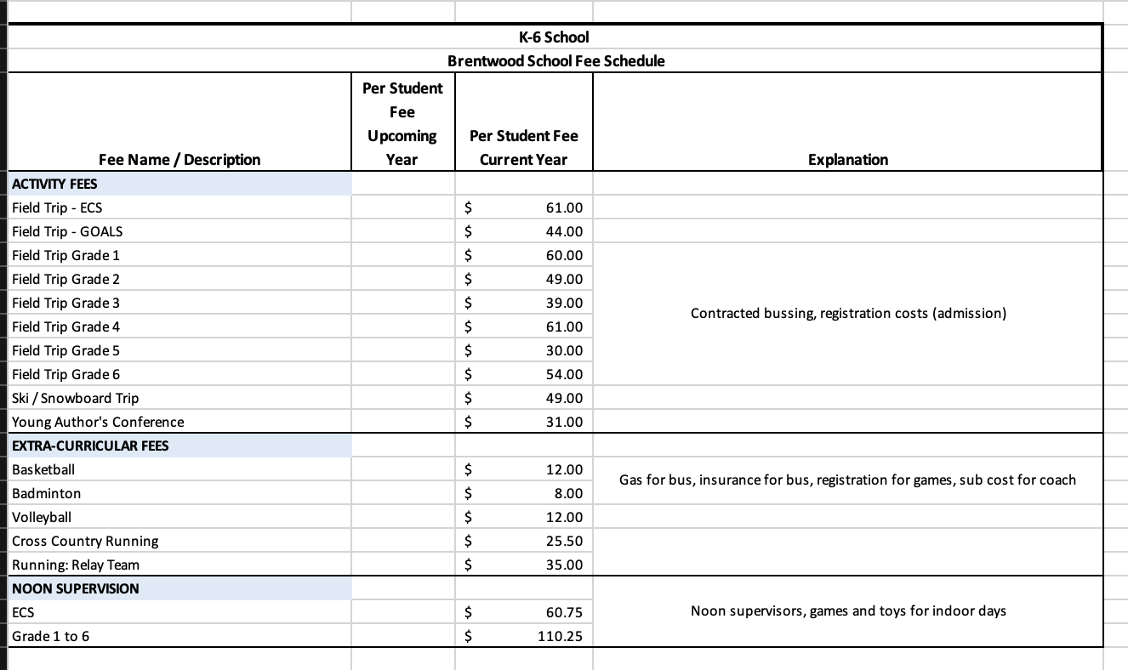
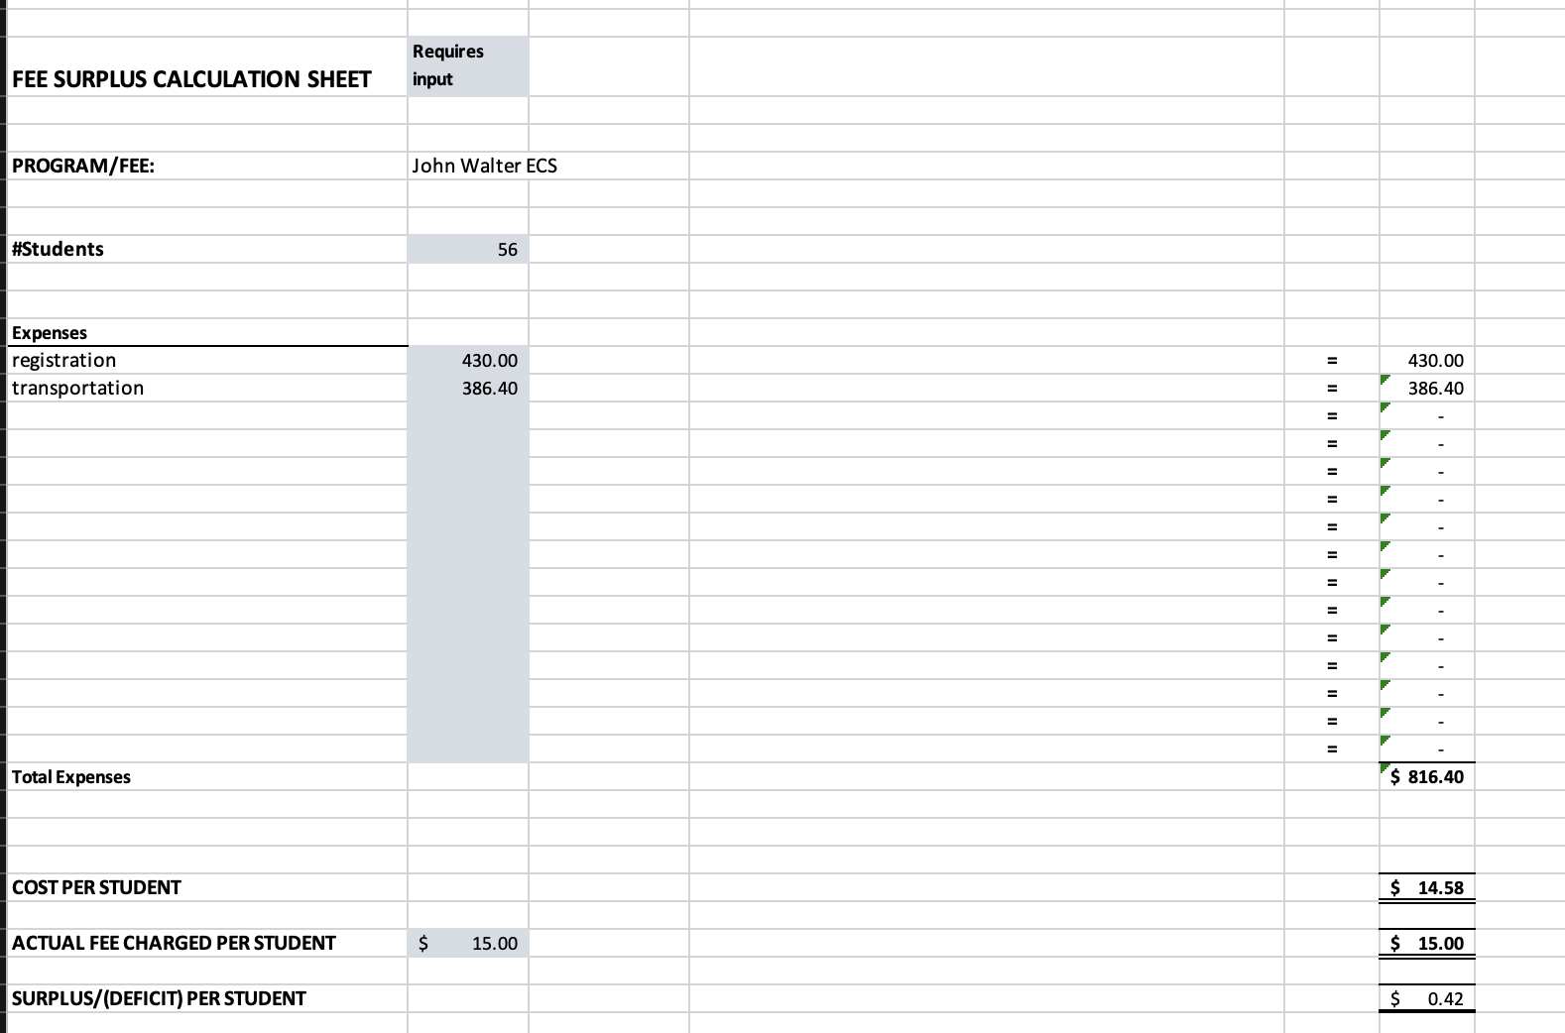

- Principal Report- Registration starts Feb 1st. Returning reg starts feb 8th for two weeks, staffing process if already begun in the district, outdoor learning space 118,000 plus installation quote that was given, facilities in earlier this week to do walk around for what needs to be done/ updated, assurance measures survey going out soon (from the provincial government for grade 4 student’s families only), fees overview and review, surveys sent out tomorrow for feedback on the fee prices, ski trip (will not be able to attend if families have not paid their school/ field trip fees, they have until March 13th to complete their payments and then they can pay and attend the ski trip), 5% increase on noon supervision every year to help with the deficit. Suggestion for grade 5/6 leadership students to be the supervision for lunch time so that screen time to be minimized.

- LOGOS Report- Kindra Varty (2 minutes)
Chapels have been going amazing. Open house held here yesterday, was attended by approx. 30 parents

- COSC Report- Brian Vick (5 minutes)
COSC Report for BESC Jan. 25/24 (these condensed notes courtesy of Emma Small EIPS)
ASCA UPDATE
The Alberta School Councils’ Association (ASCA) is the provincial organization for families on school council. Below may be of interest to COSC members.
ASCA learning opportunities and supports can be paid for using the $500 Alberta School Council Engagement grant. Workshops are offered online, scheduled weekly throughout the year.
The ASCA Conference and AGM will be held April 26-28, 2024.
The Board of Directors election will happen at the AGM on April 28. CAREGIVER EDUCATION SERIES: January
Alberta Health Services hosts a series of virtual caregiver information sessions focused on ways to support students’ mental health. The sessions are free and geared toward parents, caregivers, teachers and community members who want to learn more about challenges impacting children and adolescents. Session topics include anxiety, depression and technology, while teaching leadership skills, communication, resiliency and more.
SCHOOL COUNCIL ENGAGEMENT GRANT: Extended application deadline
The application for the School Council Engagement Grant has been extended to January 31. On November 2, school councils should have received the application to the email they provided in the contact form. If you didn’t receive this email or want more information, contact Emma Small.
ANNUAL EDUCATION RESULTS REPORT 2022-23
EIPS Associate Superintendent Ryan Marshall discussed the EIPS Annual Education Results Report 2022- 23 and its overview
MENTAL HEALTH STRATEGIC PLAN: Reset rooms
EIPS Director of Specialized Supports Marcus Reed and Mental Health Advisor Mardi Hardt presented on the reset rooms initiative from the Division’s Mental Health Strategic Plan. They spoke on how stress can be measured, and how a comfortable stress level varies from person-to-person. They provided a Steadying Strategies Checklist to COSC members in person and in the January COSC meeting package online. Hardt expressed she’d be more than happy to provide a workshop on stress to school councils and their schools, based upon scheduling availability.

Brian attended meeting and took great notes, need to figure out what we want to do with the $500 grant.

- Parking (Kindra Varty) (5 minutes)
Many parents are parking in non parking zones during drop off and pickup. There are signs posted all around the school with no parking zones as well areas where its safe to park. The drop zone is just a drop zone, no parking. As well firelane, crosswalks and bus zones need to be clear at all times. Possible suggestion would be to have parents call bylaw.

- Adjourn 7:35pm

Next Meeting: February 22, 2024

